IT RCSA Audit Documentation
Access Certification 2026 Q2 PAM BSI SOX
  - Network Device Admin Account Review (BSI.IT.27.C7)
ASSESSMENT  FAIL | REVIEW TYPE  QUARTERLY PAM | EXCEPTIONS  3 (E1-E3)

Purpose
To document the IT RCSA review of the sampled quarterly privileged access certification for BSI network devices, including the privileged network AD groups defined in the PAM Definition of Privilege, the certification population, reviewer assignment (managers and account owners), review decisions, the appropriateness of approved access, revocation of inappropriate access within SLA and compliance with the IAM Standard.
Sample quarter | 2026 Q2 (quarterly PAM access certification)
Certification | 2026 Q2 PAM BSI SOX Manager Certification and 2026 Q2 PAM BSI SOX Entitlement Owner Certification
Privileged groups sampled | CISCO ISE Administrators; CISCO Network Administrators; ISEAdmin; F5FullAdmin
Campaign launch | July 22, 2026 at 7:07 PM (Manager) / July 23, 2026 at 10:25 AM (Entitlement Owner)
Review decisions | 58 of 58 memberships Approved; 0 revoked (owner decisions July 27 - August 6, 2026)
Overall conclusion | Not compliant - exceptions E1-E3 (preliminary, pending management response)

1. Executive Summary
IT RCSA reviewed the 2026 Q2 PAM BSI SOX access certification for the four privileged network AD groups defined in section 3.3 of the PAM Definition of Privilege (CISCO ISE Administrators, CISCO Network Administrators, ISEAdmin and F5FullAdmin), the supporting CyberArk certifications, the 2025 Q2 certifications and the 2025 Q3 evidence. All 58 memberships (48 users / administrators and 10 service accounts) were included in the certification, reviewed by the user's manager or the account owner, and received a final decision. However, 30 memberships were approved although the identity was flagged inactive in IAMS (E1), carried an IAMS termination date of 12/31/2024 (E2), or had been revoked in the 2025 Q3 review and was re-granted without supporting approval (E3). The 2025 Q4 and 2026 Q1 certifications were not provided to confirm the semiannual frequency. The sample assessment result is Fail.

2. Sample and Scope
Privileged AD group | Memberships certified | User type | Scope result
CISCO ISE Administrators | 3 | 1 person / 2 service | Matched
CISCO Network Administrators | 28 | 23 person / 5 service | Matched
ISEAdmin | 23 | 22 person / 1 service | Matched
F5FullAdmin | 4 | 2 person / 2 service | Matched

3. Testing Performed and Results
Attribute | Evidence evaluated | Result | Conclusion
Frequency (A1) | Certification campaigns evidenced for 2025 Q2 (May 2025), 2025 Q3 (August 2025) and 2026 Q2 (July-August 2026). 2025 Q4 and 2026 Q1 not provided. | Pending | The semiannual frequency cannot be confirmed for the period between the 2025 Q3 and 2026 Q2 reviews.
Population completeness (A2) | All 4 privileged network groups included; 58 memberships (users, administrators and service accounts). SOX vs CyberArk manager certification 48/48 matched (2025 Q2 81/81). | Pass | Certification population is complete; current AD extract pending. Network_support (PAM Definition 3.2) outside the control scope.
Reviewer (A3) | 48/48 person memberships reviewed by the manager; 10/10 service accounts reviewed by the account owner; no self-review. | Pass | Reviews performed by managers or account owners. 9 service-account items attested by their own owner.
Review completion (A4) | 58/58 memberships with a final decision (Approved, status Complete); owner decisions July 27 - August 6, 2026. | Pass | Review was completed; SOX Manager decision dates not included in the export.
Appropriateness of access (A5) | CyberArk identity status and 2025 Q3 decisions compared to approved memberships: E1 - 5 inactive identities; E2 - 8 identities with termination date 12/31/2024; E3 - 6 memberships re-granted after 2025 Q3 revocation. | Fail | 30 memberships approved inappropriately or without support (CISCO Network Administrators 16, ISEAdmin 14).
Revocation within SLA (A6) | No revocations in 2026 Q2. 2025 Q2 revocations (10) completed and absent in 2025 Q3; 2025 Q3 revocations removed 9/2-9/8/2025 per Netwrix. | Pass | Revocations were completed within 30 business days; 6 were later re-granted (E3).
Information reliability (A7) | SailPoint exports reconciled SOX to CyberArk; SOX Manager export lacks decision dates and identity status; owner / CyberArk exports show Account Status "Account Removed" for all records. | Pass (observation) | Reports are system-generated and reconcile; field limitations noted.

Conclusion: The sampled certification is not compliant. Exceptions E1-E3 were identified in CISCO Network Administrators and ISEAdmin; CISCO ISE Administrators and F5FullAdmin passed.

4. Referenced Excel Workbook - Tab-by-Tab Guide
Purpose. The referenced workbook (BSI.IT.27.C7.02 Q2_2026.xlsx) provides the population evidence and traceability used for the sample. The summary below allows a reviewer to understand what each worksheet contains, why it is included, and how it supports the control conclusion without having to interpret the workbook independently.
Workbook tab | What the tab contains / purpose | Reviewer use and sample traceability
NETWORK ADMINS | Extract of the PAM Definition of Privilege v10.0 (March 2025), section 3.3 Network Administration, listing the four privileged network AD groups, with tester notes. | Confirms the groups in scope for the review. Compare to Appendix A and BSI.IT.27.C7.03 PAM Definition of Privilege.
1_Cisco ISE Administrators | Full 2026 Q2 SOX Manager and Entitlement Owner certification exports with the group's memberships highlighted; AD extract section (pending). | 3 memberships (1 person, 2 service) certified and Approved; no exceptions.
2_Cisco Network Administrators | Same layout; "EXCEPTIONS" USERS EVIDENCE section with CyberArk identity-status rows for each exception. | 28 memberships; 16 exceptions (E1, E2, E3). Traceable to Appendix B, Exhibits B1, B3 and B4.
3_ISEAdmin | Same layout; "EXCEPTIONS" USERS EVIDENCE section. | 23 memberships; 14 exceptions (E1, E2, E3). Traceable to Appendix B.
4_F5FullAdmin | Same layout. | 4 memberships (2 person, 2 service) certified and Approved; no exceptions.
5-SailPoint Reports | List of the certification reports used, pending items (AD extract, Netwrix logs, screenshots) and the inventory of all 8 evidence files. | Confirms every file in the evidence package was inspected and where it is used.
6_Attribute Testing | Attributes A1-A7 with policy criteria, procedures and results; item testing of all 58 memberships; timeline; SOX vs CyberArk reconciliation; revocation roll-forward. | Primary support for Section 3 and Appendix C.
Reviewer traceability
- Scope path: PAM Definition of Privilege section 3.3 -> NETWORK ADMINS tab -> Tabs 1-4 (one per privileged group) -> Appendix A.
- Review path: 2026 Q2 SOX Manager / Entitlement Owner certification exports -> Tabs 1-4 highlighted rows -> 6_Attribute Testing item results -> Appendix B.
- Exception path: CyberArk Manager certification identity status and BSI.IT.27.C7.02 Q3_2025 revocations -> "EXCEPTIONS" USERS EVIDENCE (Tabs 2-3) -> Exhibits B3 and B4.
Note: The 2026 Q2 SOX Manager export ("Validation1") identifies decision makers by employee ID; names are taken from the Access Review field.

5. Evidence Index and Audit Trail
Source | Purpose | Key support
BSI.IT.27.C7.03 PAM Definition of Privilege.pdf (v10.0, 3/11/2025) | Scope criteria | Section 3.3 Network Administration defines the four privileged network AD groups.
BSI.IT.27.C7.01 IAM Standard.pdf | Review and revocation criteria | SUS.IAMS.4.2.5.1, 4.2.5.2, 4.2.5.5-4.2.5.7, 4.2.5.9, 4.2.5.10, 4.2.5.19, 4.2.5.21 (reviewers, frequency, 30-business-day revocation SLA).
2026 Q2 PAM BSI SOX / CyberArk certification exports (4 CSV files) | Sample population and decisions | Memberships, reviewers, decisions, identity status; SOX vs CyberArk reconciliation.
2025 Q2 PAM BSI SOX / CyberArk certification exports (4 CSV files) | Frequency and roll-forward | 2025 Q2 campaigns, revocations and membership baseline.
BSI.IT.27.C7.02 Q3_2025.xlsx (2025 Cycle 2) | Prior review and revocation evidence | 2025 Q3 certification decisions and Netwrix removal logs used for E3.
BSI.IT.27.C7.02 Q2_2026.xlsx | Population and sample traceability | Seven workbook tabs documenting scope, certification data per group, report inventory and attribute testing.
WP2 BSI.IT.27.C7.xlsm | Testing workpaper | Control metadata, design assessment and performance assessment (attributes by group, rating Needs Improvement).

6. Audit Conclusion
Based on the evidence reviewed, IT RCSA concluded that the 2026 Q2 PAM BSI SOX certification covered all members of the privileged network AD groups defined in the PAM Definition of Privilege and was performed by managers and account owners with a recorded decision for every membership. However, the review approved privileged network access for identities flagged inactive or terminated in IAMS and for memberships re-granted after revocation, so inappropriate access was not identified or revoked. The 2025 Q4 and 2026 Q1 reviews were not evidenced. The control sample assessment result is Fail (preliminary, pending management response and the outstanding evidence).

Appendix A - PAM Definition of Privilege Evidence
Exhibit A1: PAM Definition of Privilege v10.0 - Section 3.3 Network Administration
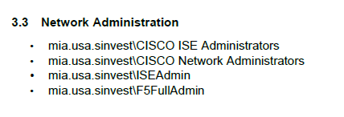

Section 3.3 defines mia.usa.sinvest\CISCO ISE Administrators, CISCO Network Administrators, ISEAdmin and F5FullAdmin as the privileged network administration groups in scope of the PAM certification. Section 3.2 also lists mia.usa.sinvest\Network_support ("Network devices Administrators"), which is not included in the control scope.
Source: BSI.IT.27.C7.03 PAM Definition of Privilege.pdf (page 7)

Appendix B - Certification Review Evidence
Exhibit B1: 2026 Q2 PAM BSI SOX Manager Certification - privileged network group memberships
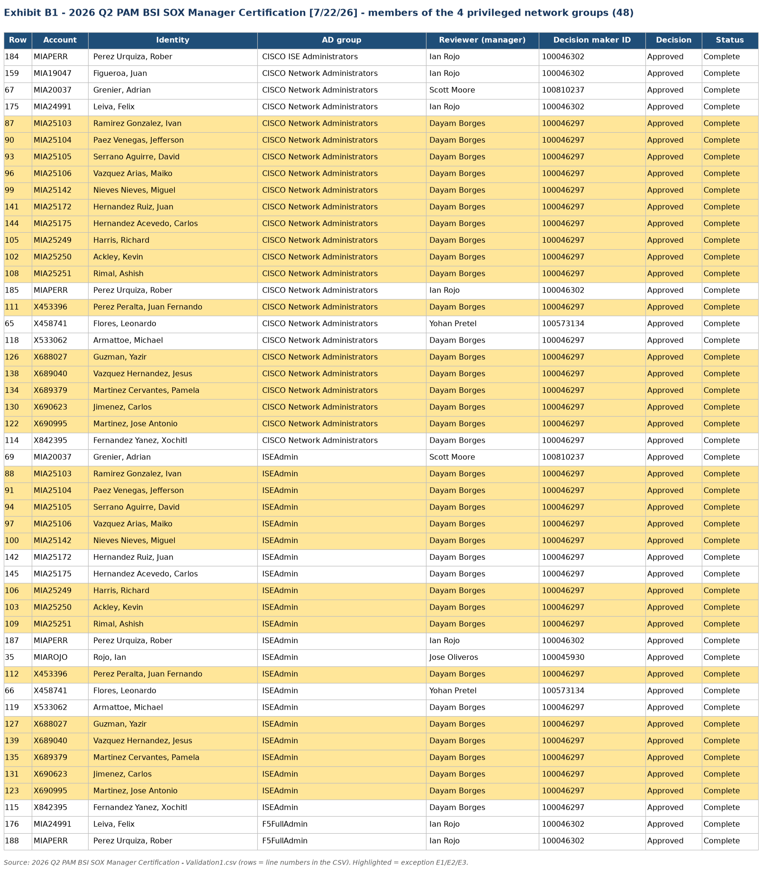
Source: 2026 Q2 PAM BSI SOX Manager Certification - Validation1.csv (extract rendered from the source file)

Appendix B - Certification Review Evidence
Exhibit B2: 2026 Q2 PAM BSI SOX Entitlement Owner Certification - service accounts
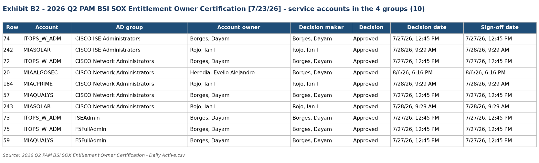
Source: 2026 Q2 PAM BSI SOX Entitlement Owner Certification - Daily Active.csv (extract rendered from the source file)

Appendix B - Certification Review Evidence
Exhibit B3: IAMS identity status of approved network administrators (E1 / E2)
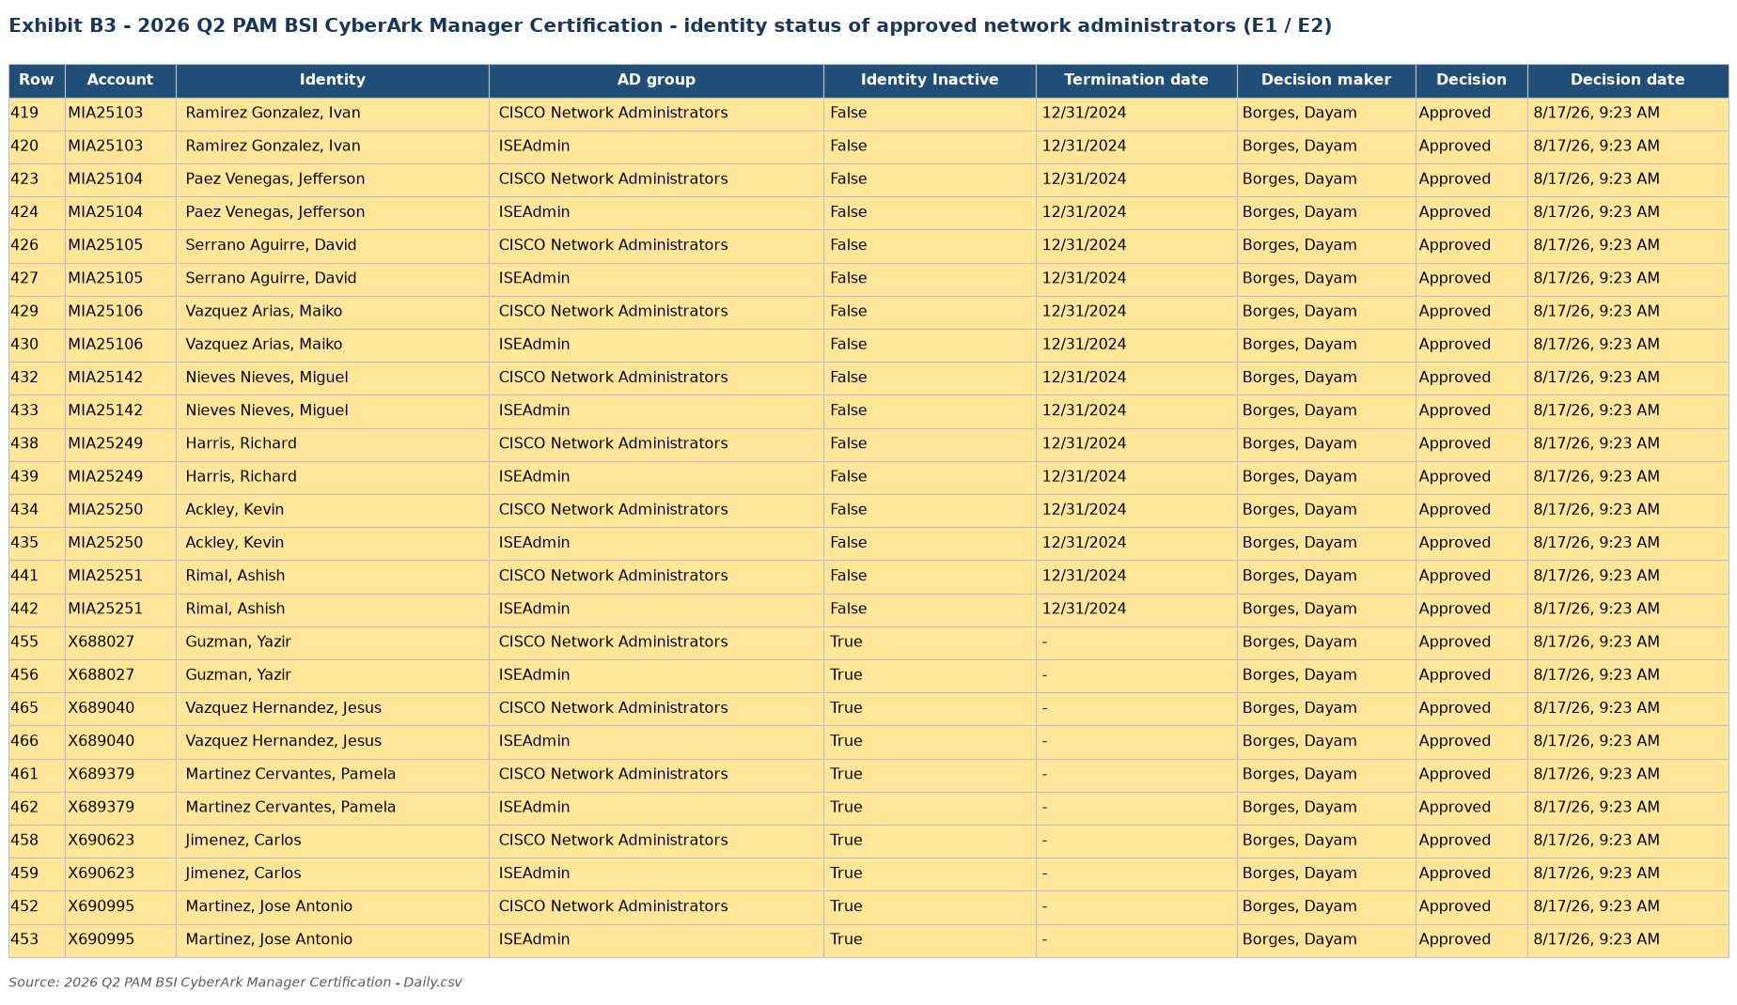
Source: 2026 Q2 PAM BSI CyberArk Manager Certification - Daily.csv (extract rendered from the source file)

Appendix B - Certification Review Evidence
Exhibit B4: Memberships revoked in 2025 Q3 and approved again in 2026 Q2 (E3)
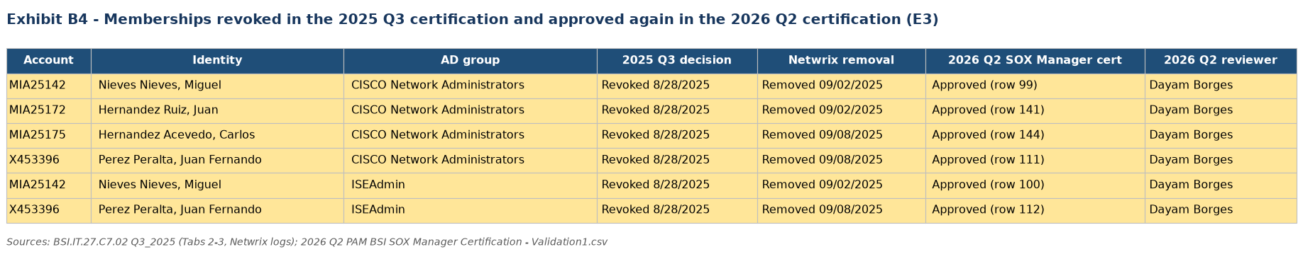
Source: BSI.IT.27.C7.02 Q3_2025.xlsx; 2026 Q2 PAM BSI SOX Manager Certification - Validation1.csv (extract rendered from the source file)

Appendix C - Population and Frequency Evidence
Exhibit C1: Certification population completeness and campaign frequency
The certification population of the four privileged network groups was validated as follows:
- SOX Manager certification membership reconciled to the independent CyberArk Manager certification of the same AD groups (2026 Q2: 48/48; 2025 Q2: 81/81)
- Service accounts in the SOX Entitlement Owner certification compared to the CyberArk Entitlement Owner certification (2026 Q2: 8 of 10)
- Certification campaigns evidenced for 2025 Q2, 2025 Q3 and 2026 Q2; 2025 Q4 and 2026 Q1 not provided
The reconciliation confirmed that all members certified through CyberArk were also certified in the SOX certification; MIAALGOSEC and MIACPRIME appear only in the SOX owner certification.
Result: Pass (population); Pending (frequency)
Conclusion: The certification population is complete for the four groups; the semiannual frequency requires the 2025 Q4 / 2026 Q1 certifications or management confirmation.
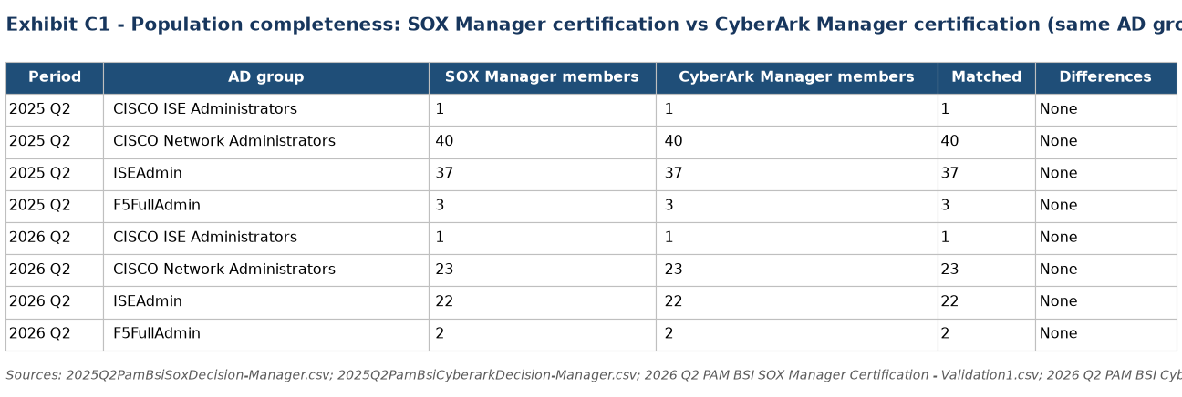
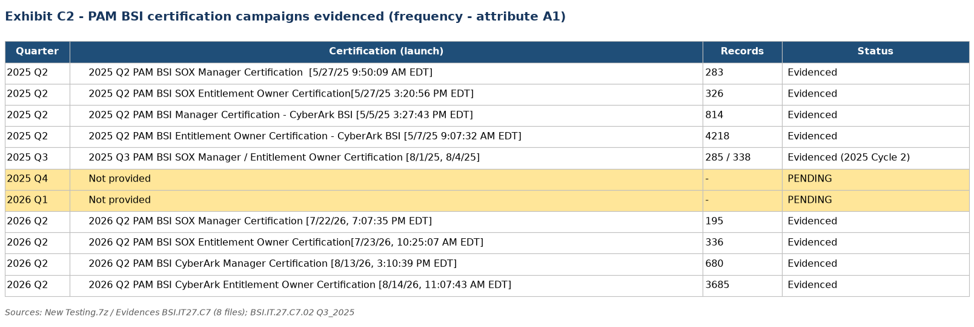

Source: PAM BSI SOX and CyberArk certification exports 2025 Q2 and 2026 Q2 (extracts rendered from the source files); BSI.IT.27.C7.02 Q3_2025.

Appendix D - Auditor Testing Narrative and Referenced Workbook
IT RCSA validated the Network Device Admin Account Review control by confirming the privileged network AD groups against the PAM Definition of Privilege, verifying that the 2026 Q2 certification included all administrators, users and service accounts of those groups, that each membership was reviewed by the user's manager or the account owner and received a final decision, assessing whether approved access was appropriate using IAMS identity status and prior revocations, and rolling forward prior revocations to confirm removal within the 30-business-day SLA. Testing identified exceptions E1-E3 in CISCO Network Administrators and ISEAdmin; the frequency attribute remains pending the 2025 Q4 and 2026 Q1 certifications.
Referenced Excel Workbook: BSI.IT.27.C7.02 Q2_2026.xlsx. See Section 4 for the tab-by-tab explanation and reviewer traceability.

